While maintaining your website, at some point you may want to add a image to the site. The following steps will guide you through adding an image and providing alternative text for that image on your website.

For the following examples I am going to use a few pages created for specifically for webmaster training.

First off, make sure you have added the new image into your images folder for your site. You’ll see below, that I have added an image named governor.gif to the images folder of the webmaster training website.
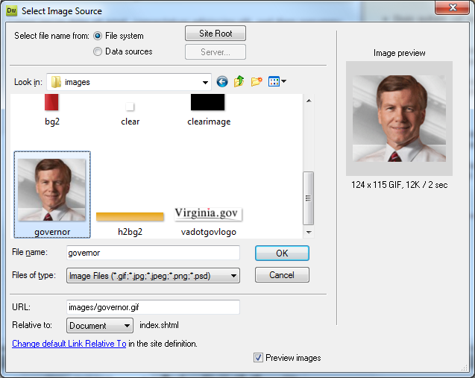

Open a page in Dreamweaver and using your cursor, select where you want to place your image on your webpage. Then go up the menu at the top of Dreamweaver and select Insert then select image, from the insert menu.
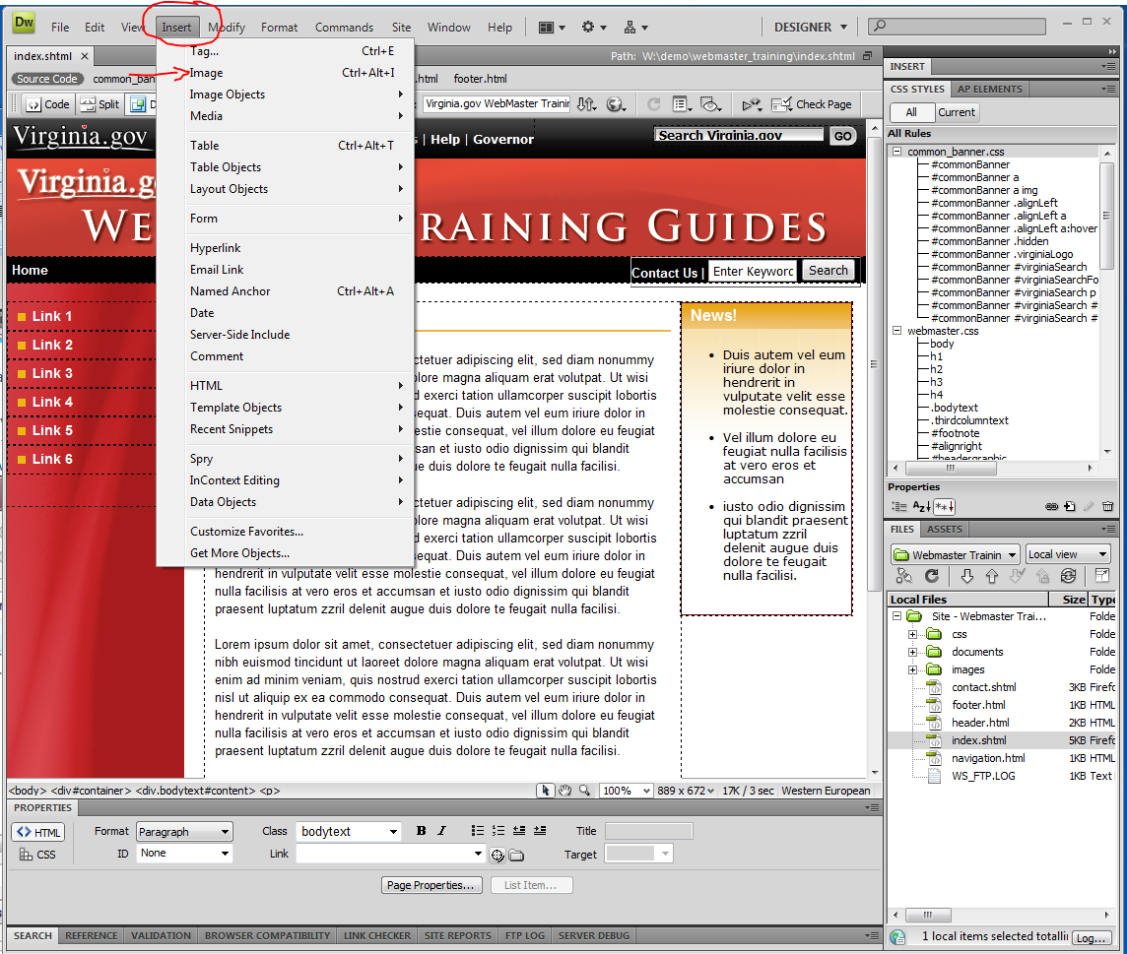

Find the image you want to place into your webpage. For this example I am going to choose the governor.gif image. Then click OK.

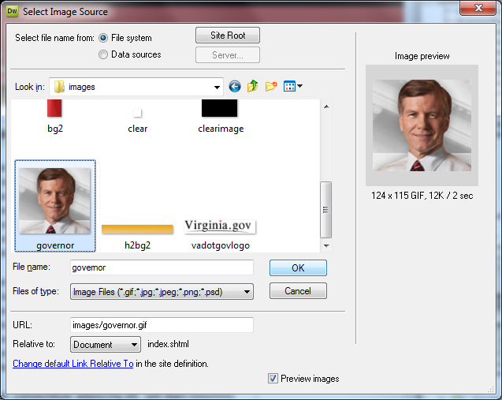

A dialog box will appear asking for Image Tag Accessibility Attributes which is commonly referred to as alt text. Type in a brief description of the photo you are placing into your webpage in the Alternative text box. You will see where I have typed Governor Bob McDonald into this box. Once you are done, click OK.

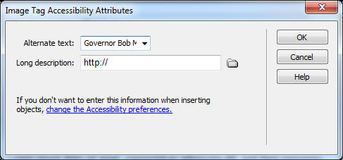
Now that the image has been placed into your webpage, you can make some choices using the tools in the PROPERTIES box. When you click on the image to select it, your choices will appear. You can add a border, change the alignment, or add padding (V and H space) around the image.

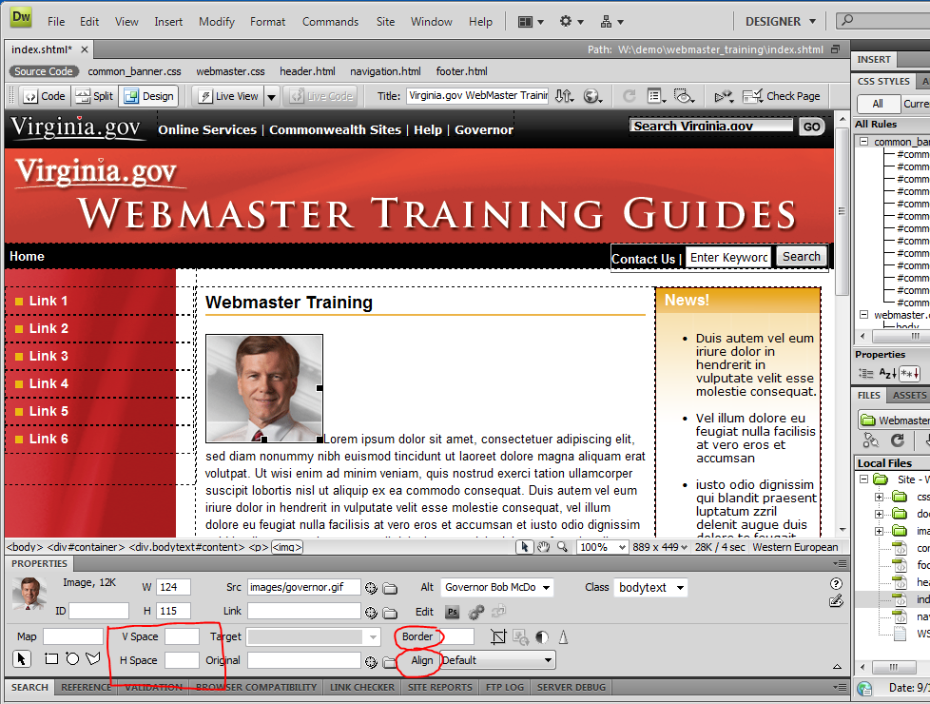

For Example:

You can see where I made some adjustments in the properties box for the governor.gif image below. I set the border to zero, aligned the image to the right, and gave the image an H space of 7. You can do the same with the image you add to your site or do what will work best for your site.

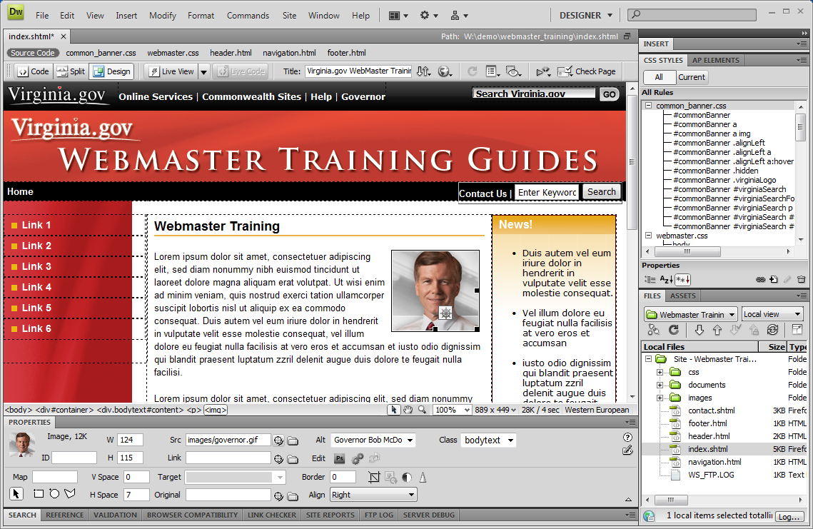

Once you have completed your edits/changes, save then upload them to your live production area. And that’s it!

Please NOTE: You will need to make sure you upload the image before you upload the page to your site.

